Lab 8-1 inheritance 1

1. Code in the folder “week6”.
2. Create the Super class as name “Person” and subclass as name “Artist”. Following example

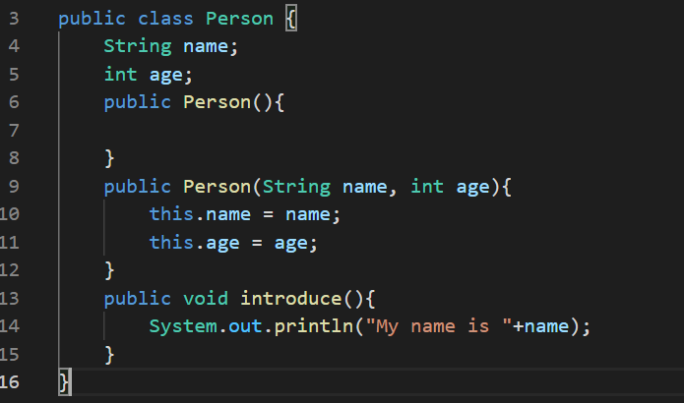

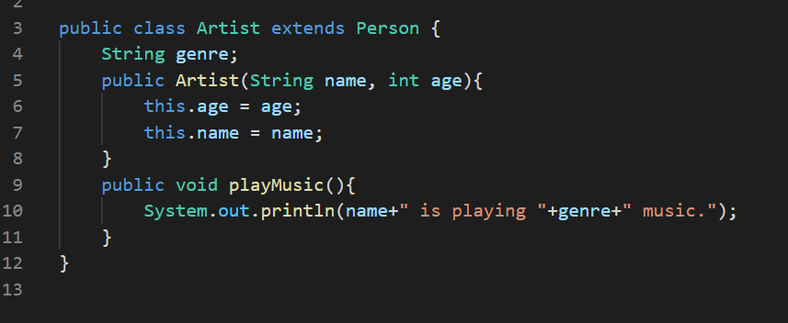

1. Create a main program to run all classes.

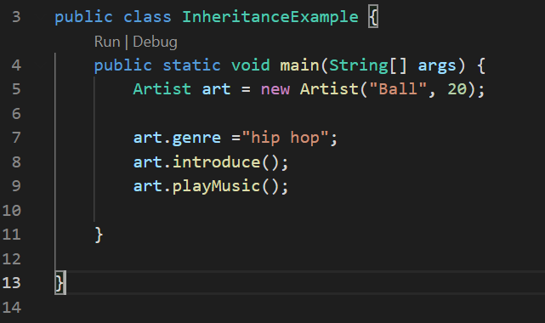

1. Compile and run the main program



1. Add the gender attribute for the person.
2. Edit the introduce() for display the name, age, and gender
3. Create five sub classes to define difference job of the person. Example engineer, doctor, ….

\*write your name and ID in the code as the comment. //Kittitouch Suteeca 6321100001

\*\*submission Thu 14 Jan 2021, before 22.00 in the github.

\*\*\*submit last week lab(7-1,7-2) in the github put your work in the folder “week5”